Title in 14-Point Times New Roman Bold
Centred Across the Whole Page
[blank 14 point line ]
John B. Author
School of Information Technology and Electrical Engineering
The University of Queensland, Qld., 4072, Australia
[2 blank 12 point lines]

Abstract
All the text of the paper is based on Times New Roman or a similar font. The abstract heading is in 11 point bold, centred in the column. The text of the abstract is 11 point italic and can be up to 150 words or 75mm in length. The text of the abstract plus keywords, title, authors and affiliation would normally be submitted as plain text to allow a searchable index to be created, but this is not a requirement here.
Paragraphs have no extra line-space but the first word is indented by 5mm. Text is fully justified, left and right.

1 Headings and Paragraphs
Paragraph text is in 10 point Roman with an additional 2 points of line spacing, fully justified. The section headings are 12 point bold. Leave one blank line before and one blank line after the heading but leave two blank lines between the end of the abstract and the first heading.
2 Margins and Paper Size
The conference paper should be formatted for A4 size paper. A4 measures 210mm wide by 297mm high. Each paper should be no longer than the maximum number of pages specified and no shorter than one page less than this.
The left and right margins will be 25 mm. The top and bottom margins are 30 mm. There will be a header on every page, except the first page, which contains the title of the paper. You will need to add this header to your document. The page number is centered at the bottom of each page.
3 Column and Tab Settings
The body of the paper is printed in two columns with a space between columns of 7 mm. The resulting columns will be 7.64 cm wide.
Where footnotes have to be inserted, they must run across the entire bottom of the page. On the final page, the two columns should be balanced in length.
To give a balanced indent to paragraphs, the first tab stop should be set to 5 mm.

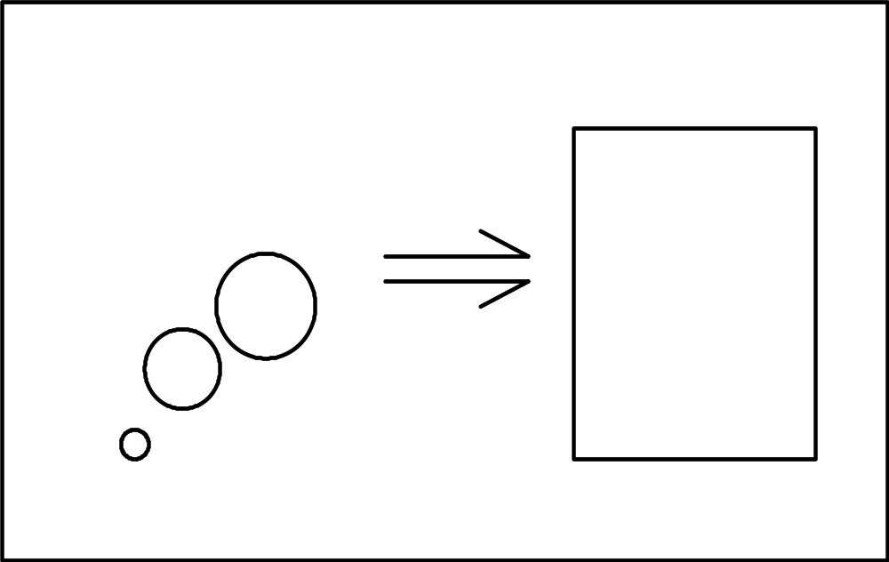
Fig 1. Meaningful diagram (10 pt itl Times New Roman)
4 Figures and Illustrations
Figures can be fitted within the columns (see Fig. 1) or, if necessary, they can spread across the full page but keep the text to the two-column format. It is best to place a full-width graphic at the top or the bottom of the page to avoid visual confusion with broken columns – as shown in Fig. 2.
Captions are in 10-point Times New Roman. Use italics to emphasis these captions.
Any images must be included as part of the file. Carefully consider the size of lines and fonts used in diagrams and plots to ensure they remain clear in the final copy. When selecting colour images or using colour in diagrams and plots, give some thought to legibility and clarity were the paper to be printed in black-and-white.
5 References to References
A reference is made with a number in square brackets [1]. If the reference is important to the discussion—say, you intend to spend most of the paragraph discussing it—then you should use the author names as well. For instance, Shannon [5] was the first to show that a noisy channel can be used to communicate information at a non-zero rate without error. Wolniansky et al.[6] advanced the start of the art significantly when they described the V-BLAST scheme for wireless MIMO communications…
Acknowledgment
You may wish to add an acknowledgment before the references.
The references should be typed in 10 point text after a 12 point bold heading.
References
- A. B. Smith, C. D. Jones, and E. F. Roberts, “Article title,” Journal, vol. 1, no. 1, pp. 1-10, Date.
- C. D. Jones, A.B. Smith, and E.F. Roberts, Book Title, Publisher, Location, Date.
- C. D. Jones, A. B. Smith, and E. F. Roberts, “Article title,” in Proceedings Title. IEEE, 2003, vol. II, pp. 803–806.
- Gene H. Golub and Charles F. Van Loan, Matrix Computations, Johns-Hopkins University Press, 3rd ed., 1996.
- Claude E. Shannon, “A mathematical theory of communication,” Bell Syst. Tech. J., vol. 27, pp. 379–423, 623–656, Jul./Oct. 1948.
- P. W. Wolniansky, G. J. Foschini, G. D. Golden, and R. A. Valenzuela, “V-BLAST: An architecture for realizing very high data rates over the rich-scattering wireless channel,” in Proc. URSI Internat. Sympos. Signals Syst. Electronics, pp. 295–300, Sept. 1998.
- Motorola, Inc.: DSP56002 Users Manual, 1993.
Biography
You should add a biography after all other material. The biography should focus on your professional accomplishments and interests, although can add some personal notes as well. Please keep it to less than 100 words.
Fig 2. Further and deeper thoughts (10 pt italic Times New Roman)

